**Library Management System Project Report**

1. **Formalized Proposal**

Library management system is a computerized system which helps user(librarian) to manage the library daily activity in an electronic format. The main purpose of this system is to reduce the risk of paperwork such as file lost, file damaged and time consuming. It can help user to manage the transaction or record more effectively and timesaving.

The Library management system aims at developing a fully functional computerized system to maintain all day to day activity of a library. Another aim of this system is to make sure books are arranged in order (alphabetical order by subject) which make retrieval of the books faster when searching for check out.

* 1. **Introductory paragraph describing your project from generic to specific**

This project is designed to manage high school student library with the main purpose of tracking current books in the library and the issued-out books. The project “library management system” is developed in Java, which mainly focuses on basic operations in a library like adding new books and updating new information.

One can enter the record of new books and retrieve the details of books available in the library. We can issue the books to the students and maintain their records and can also check how many books are issued and stock available in the library.

The use of data structure is the main focus of this project and how each data structure is used. There are three data structures used in this project which include, ArrayList, HashMap and LinkedList. I have used ArrayList to store the name of the books category that is biology books, chemistry books and physics books. ArrayList is also used to store the name of the author of the books. LinkedList is used to store the books in the individual shelf in alphabetical order using sort data structure. HashMap is used when checking out the book or books in each individual shelf that is biology shelf, chemistry and physics books shelf to check out shelf.

In the project am using dlm1 to represent biology shelf, dlm2 to represent chemistry shelf, dlm3 to represent physics shelf and dlm4 to represent checked out books shelf. On checking out a book, one double clicks on the book in the specific shelf. The clicked book is move from the respective shelf to check out shelf which is dml4. To remove the book from the shelf the use of dlm1.remove(index)line of code is used for example checking out book in the biology shelf.

* 1. **Paragraph(s) describing your project**

The project aim is to store books in different shelves by subject:

* Shelve one – biology books
* Shelf two – chemistry books
* Shelf three - physics books
* Checked out books

The books in the shelves are stored in a LinkedList and sorting of the books in alphabetical order is done using sorting and HashMap. When checking out a book or books, the librarian doubles clicks on the desired booked in a shelf. The book is moved from either shelf dml1, dml2 or dml3 to shelf 4 which is dml4 where checked out books are held till, they are returned. Inside the code if an element is removed from dlm1 (which is biology books shelf), the element is then added to dlm4 (which is the checked books shelf). I have used **dlm1.remove(index)** to remove an element index to a temp location in dlm4 and an example.

1. **Time/Change Logs**
   1. **If you kept daily or change logs**

My project logs ranges from May 20th, 2020 to June 12th ,2020.

* 1. **Paragraphs describing a time quantum (day/week) and what you accomplished**

May 20th, 2020 On this day I drafted my project proposal and below is the detailed report on the proposal.

**Project proposal**

1. ***Problem diagnosis:***

My proposed project is a library management system designed to be used in school library. The problem diagnosis is how to implement the system that will manage books in the library in an automated way eliminating paperwork process. The system should be able to manage books in the library and be able to issue books in the most effective and efficient manner. The system should also be able to manage returned issued books the respective shelves they belong. In the development of the system, I will be using java programming language and my focus is to use as many data structures as possible to be able to design and implement project.

1. ***Proposed solution***

The first aim is to design a user-friendly graphical user interface. The second aim is to implement this project using three classes. The first class will be called books which will be the base class and data will be encapsulated. The second class is called booklist which will store the books name and authors of these books in ArrayList. My third class is LMSGUI which is the graphical user interface class which implements Books and Booklist classes.

1. ***Work Plan***

Below is the work plan to for the proposed design of the interface.

* Gather user requirements – 3 days approximately.
* Design and coding – 2 weeks.
* Testing - 3days.
* Final project ready for implementation.

*May 21st, 2020*

* Researched on different data structures and how they are implemented. Most of my research was on YouTube as well as on google. I spend *3 hours* researching.

*May 22nd, 2020*

* Researched more on different library management systems mainly on the functionality and not paying attention to the language used. Spend 3 hour on this.

*May 23rd, 2020*

* Researched on different data structures and how they are implemented. Most of my research was on YouTube as well as on google. Spend *2 hours* researching.

May 24th ,2020

* Designed a road map in terms of the classes I need and how they will be connected to each other. This was more of a pseudocode and not in detailed. Spend 4 hours in this.

May 25th ,2020

* Designed a pseudocode to give me a clear picture on how I wanted the application to work. Spend 3 hours on this.

May 26th ,2020

* Started the design phase of the system with designing Book, Booklist and a bit of LMSGUI classes. Spend 4 hours

May 27th ,2020

* Designing graphical user interface. Spent 4 hours

May 28th ,2020

* Designing graphical user interface and coding.
* Tested the system mouse click functionality to make sure working fine. Spend 5 hours

May 29th ,2020

* More designing graphical user interface and coding.
* Testing more system functionality and fine tuning the code especially LMSGUI class. Spent 3 hours.

May 30th ,2020

* Designing graphical user interface and coding.
* Testing more system functionality and fine tuning the code especially LMSGUI class. Spent 2 hours.

May 31st ,2020

* Testing more system functionality and fine tuning the code especially LMSGUI class. Spent 1 hours.

June 1st ,2020

* Documenting my project report. Spent 1 hours

June 2nd ,2020

* Documenting my project report. Spent 1 hours

June 3rd ,2020

* Documenting my project report. Spent 1 hours

June 4th ,2020

* Documenting my project report. Spent 1 hours

June 5th, 2020

* Documenting my project report. Spent 1 hours

June 6th ,2020

* Documenting my project report. Spent 1 hours

June 7th ,2020

* Documenting my project report. Spent 1 hours

June 8th ,2020

* Documenting my project report. Spent 1 hours

1. **Lessons Learned**
   1. ***Talk about the scope of your project and if it changed.***

Overall, the project is developed to help the students as well as staff of library to maintain the library in the best way possible and reduce the human efforts.

* 1. ***What blockers you encountered and the solutions you found***

My main blocker during the entire project is suitable time to accomplish each day’s milestone. I have two 2020 summer semester classes that is Python and Environmental Science which are consuming more time as I have to submit my weekly assignments on time. The classes being fully online too I had to do a lot of research on my own for both classes and the project.

On February 20th I was blessed with a baby boy named Nathan. As I began my project on 30th May 2020, he was 2 months old as he needed more attention, I had to help my wife as she recuperated, take care of my two-year-old daughter (Samantha) and I have a full-time job. It was not easy but with well-planned time management I was able to handle all.

I came up with timetable to woke up at 4am before everybody wakes up and do my assignments and this project. Each day I made sure at least I spend 4 hours minimum on the project. The rest of the obstacle were errors in the code which with google and you tube help I was able to get solution.

1. **CODE including comments**
   1. A link to your GitHub repo (.java files on GitHub that include comments and Javadoc)

<https://github.com/pnthairu/Data_Structure_Project-LibarayManagmentSystem>

1. **User's Manual**
   1. Explain how to run and interact with your program.

How the system works is there is only one graphical user interface (GUI) as per the below screen shot.

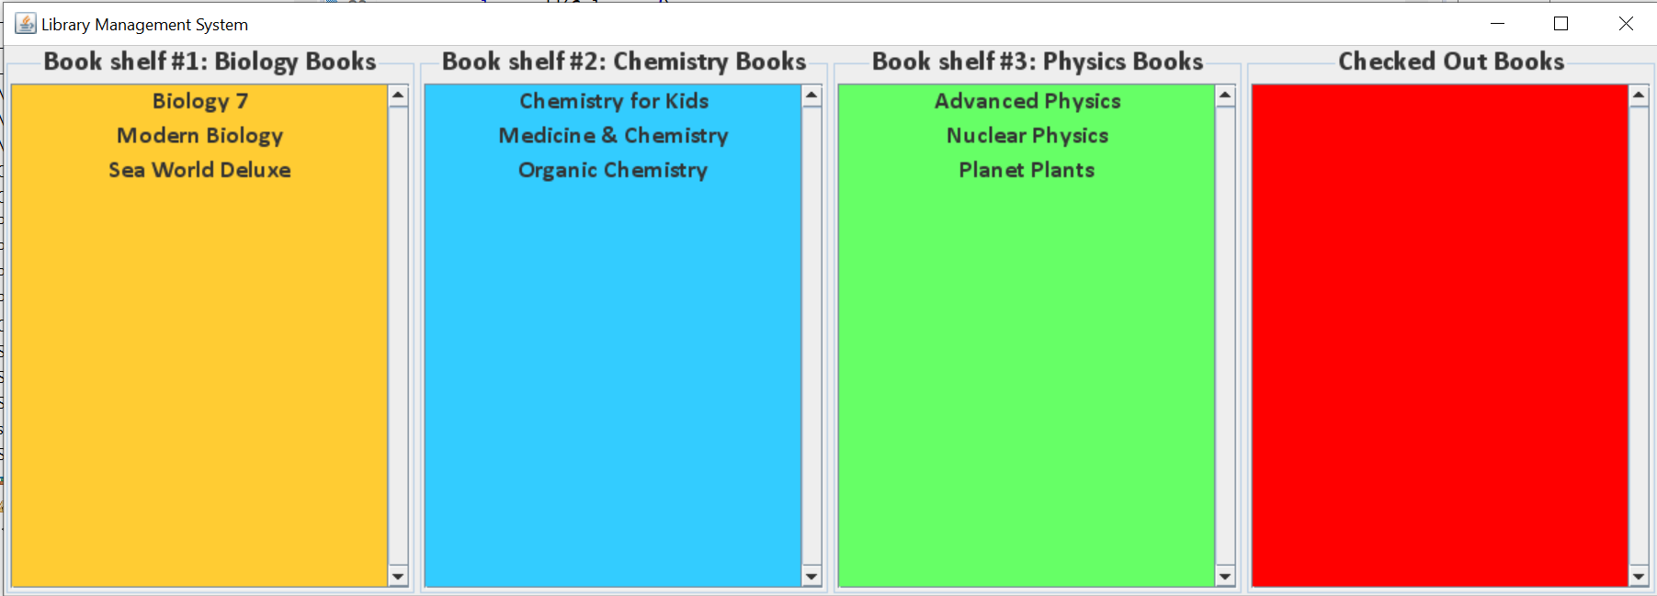

The Librarian selects the book or books to be checked out by double clicking on the book or books at a time in the respective shelf. After double clicking on the book, the book is moved to the checked-out shelf pane which will store a list of all checked out books.

Once the book or books are returned by the student, the Librarian on the checked out window double clicks on each book one by one and the books is moved back to the respective shelf.

1. **Conclusion/Summary**
   1. **A paragraph describing MERUSE (Michelle's principles of good programming found in an early Module folder Java Review) applied to your code.**

The use on encapsulation, inheritance, and abstraction for me a good programming practice. To me the process of hiding information details and protecting data and behavior of an object from misuse by other objects is a very good programming practice. To me the use of ArrayList over array is that you can define ArrayList as re-sizable array. Size of the ArrayList is not fixed. ArrayList can grow and shrink dynamically. To me this a good, efficient, and effective way of a good programmer.

* 1. ***A paragraph summarizing your project***

This project has enabled me to more comfortable with Java and well as object-oriented programming. The use of data structure for the first time was amazing and learning how to apply Linked list and hash map data structures into practice has been a big eye opener for me. This project has made feel more confident to face the job market as the whole project felt like real life experience project. This was a very user-friendly project to handle from the beginning to the end with minimal issues.

* 1. ***A paragraph of future versions***

With the current market converting most application to web- based, the same will apply to this application. Future release version will be web based and this is something I am excited and looking forward to implementing it.